WORLD RECIPE APPLICATION

A PROJECT REPORT IS PRESENTED IN PARTIAL FULFILMENT

OF THE REQUIREMENT FOR THE DEGREE

B.Tech

IN

INFORMATION TECHNOLOGY

BY

SWAROOP ACHARJEE

REGISTRATION NUMBER-131170110177

ROLL NUMBER- 11700213084

NISHTHA AGRAWAL

REGISTRATION NUMBER- 131170110134

ROLL NUMBER- 11700213041

ARVIND KUMAR

REGISTRATION NUMBER- 131170110130

ROLL NUMBER- 11700213013

AT

RCC INSTITUTE OF INFORMATION TECHNOLOGY

*[AFFILIATED TO MAULANA ABUL KALAM AZAD UNIVERSITY OF TECHNOLOGY]*

CANAL SOUTH ROAD, BELIAGHATA, KOLKATA-700015

CONTENTS

CHAPTER 1

A. Abstract --------------------------------------------------------------------------------------2

B. Introduction-----------------------------------------------------------------------------------3

C. Benefits---------------------------------------------------------------------------------------4

D. Platform Specification-------------------------------------------------------------------------5

CHAPTER 2

A. Objectives------------------------------------------------------------------------------------7

CHAPTER 3

A. System Analysis--------------------------------------------------------------------------11

B. Development cycle

CHAPTER 4

A. Data Flow Diagrams

B. Entity Relationship Diagram

C. Database Specification

CHAPTER 5

A. Snapshots

B. Coding

CHAPTER 6

A. Testing

B. Maintenance

C. Future aspect

D. Reference

RCC INSTITUTE OF INFORMATION TECHNOLOGY

KOLKATA-700015, WEST BENGAL, INDIA

**CERTIFICATE OF ACCEPTANCE**

*The report of* ***the project titled ‘****WORLD RECIPE APPLICATION****’*** *submitted by SWAROOP ACHARJEE (Roll- 11700213084), NISHTHA AGRAWAL (Roll-11700213041) and ARVIND KUMAR (Roll-11700213013) of IT DEPARTMENT for 7th semester of 2016 has been prepared under supervision for the partial fulfillment of the requirement* ***B.Tech degree of Maulana Abul Kalam Azad university of Technology (MAKAUT).***

Name of Group Members Signature with date

Member - I ----------------------------

Member – II -----------------------------

Member - III -----------------------------

Signature of the Project Guide ------------------------

Krishna Pal

(Senior Software Engineer)

Ashtik Softech Pvt. Ltd

**ACKNOWLEDGEMENT**

Before starting this project report I would like to add a few heartfelt words to those people who helped directly or indirectly for standing up of the project in numerous ways; people who gave unending support right from the concept evoked in my mind.

I take this opportunity to express my profound gratitude and deep regard to my mentor Mr. Krishna Pal, for his exemplary guidance, monitoring and constant encouragement throughout the course of the project. The blessing help and guidance given by him time to time shall carry me a long way in the journey of life on which I am to embark.

The list of such supportive personal goes endlessly but there is someone who deserves to be mentioned. I specially thank my project team members for his invaluably constructive criticism friendly advice during the project work. I am sincerely grateful to him for sharing his truthful and illuminating views on a number of issues related to the project.

**ABSTRACT**

World Recipe is an application which aims in developing a computerized system to maintain several different types of recipes from all around the globe on a single platform.

The project aims to provide a platform where anyone can view, upload and share any recipe he/she likes.

The system has facilities for creating one’s own profile and login. Regular users can view all the recipes which are categorized and like and share them. To upload one’s own recipe, registration is required.

Top rated recipes are displayed on the home page. One can upload as many recipes he/she may like and also edit it.

**INTRODUCTION**

Cooking has recently emerged as a very popular hobby and people want to try out delicacies from all around the globe. They want to experience the global gastronomical pleasures from the comfort of their home. There are plenty of websites that offer recipes but none offer recipes from all parts of the globe categorized under several categories and allow users to share their own recipes too.

This application is designed to overcome these drawbacks and provide a common platform to both the general users and chefs/cooks from around the world to share their recipes and categorize them so that more people can try them out and give their feedback.

BENEFITS OF THE PROJECT

1. Provide a single platform for all recipes

2. Create a social network of people interested in cooking

3. Give free access to unlimited recipes from all over the world

4. Promote a sense of sharing of different cultures

5. Provide a wide variety of categories to choose from

6. Motivate amateurs to create more recipes

7. Improve efficiency in managing new ideas

8. Reduce efforts spent on finding multiple recipes  
9. Enable crowd sourcing

10. Increase the relationship between different people

**PLATFORM SPECIFICATION**

Platform is an underlying computer system on which application programs can run. It is the hardware and software architecture that acts as a base. Computer system consists of two major elements: hardware and software.

HARDWARE REQUIREMENT:-

1. Processor - Pentium 2 or higher
2. Processor Speed - 512 MHZ
3. Hard disk – 250GB minimum
4. Ram memory – 2GB minimum

SOFTWARE REQUIREMENT:-

1. Operating system - Windows 2000 or higher
2. Software used - Visual Studio
3. Front End - ASP.NET, CSS, HTML
4. Back End - SQL SERVER

**OBJECTIVES**

**These are the following objectives of our Project:**

1. To share a wide variety of recipes with others.
2. To provide a single platform for sharing and viewing of several recipes
3. To help amateur chefs create a network of similar people

**SYSTEM ANALYSIS**

System analysis is the detailed study of the various operations performed by the system and their relations within an outside the system. It is a systematic technique that refines goals and objectives.

The goal of the system development is the heart of this process. One of the best approaches to system analysis is the structured analysis.

Structured analysis is a set of techniques and graphical tools that allow the analyst to develop a new kind of system specification that are easily understandable to the user. It is detailed step by step investigation of related procedures to see what must be done and to determine the best way of doing it. In structured analysis the following tools are used:

 Context Diagram

 Data flow diagram

 Data dictionary

 Structured English

 Decision trees

 Decision table

The selection of these tools may vary from project to project. For the system under consideration, we select the tool, which we find to be suitable for the project. The structured analysis tools, used in the project are context diagram and data flow diagram.

**Clear summarization of the Project**

1.) The Project is about World Recipe Application.

2.) The Project is developed in ASP.NET framework 2010.

3.) Language used for the Project is VB (Visual Basics).

4.) DBMS used in the project is Microsoft SQL

5.) Designed in HTML5 and CSS.

**DEVELOPMENT CYCLE**

**What our Project will do?**

***Registration of the User***

A registered user will be able to upload his/her recipes and edit them whereas a general user will only be able to view the recipes.

***Sign In***

The users, who are already registered, can sign in by using their username and password.

***Profile handling***

Every single user is able to modify their profile such as change password, change picture or can delete account.

***Add Recipes***

Registered users are able to upload recipes and edit them.

***View Recipes***

Any user is able to view all the recipes under various categories.

***About page***

By clicking the about page users are able to know the detail about the developer who created the application.

***Sign out***

By clicking the sign out users can successfully logging out from the application.

**Data Flow Diagram**

***What is Data Flow Diagram?***

The DFD (also known as a bubble chart) is a hierarchical graphical model of a system that shows the different processing activities or functions that the system performs and the data interchange among these functions. Each function is considered as a processing station (or process) that consumes some input data and produces some output data. The system is represented in terms of the input data to the system, various processing carried out on these data, and the output data generated by the system. A DFD model uses a very limited number of primitive symbols to represent the functions performed by a system and the data flow among these functions.

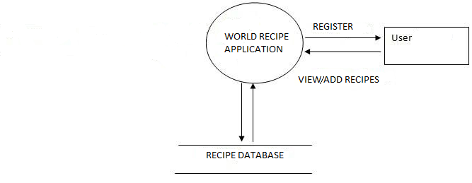

DFD Level-0 diagram

**Entity Relationship Diagram (ERD)**

***What is ER diagram?***

An entity-relationship diagram (ERD) is a graphical representation of an information system that shows the relationship between people, objects, places, concepts or events within that system. An ERD is a data modelling technique that can help define business processes and can be used as the foundation for a relational database. While useful for organizing data that can be represented by a relational structure, an entity-relationship diagram can't sufficiently represent semi-structured or unstructured data, and an ERD is unlikely to be helpful on its own in integrating data into a pre-existing information system. It is a logical structure of databases. It is the visual representation of data that describes how data is related to each other.

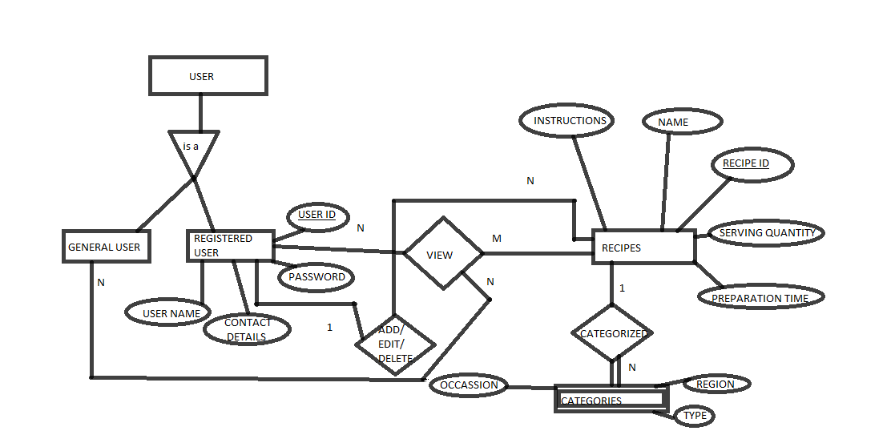

1 POSTS

ERD (entity relationship diagram)

**DATABASE**

A **database** is an organized collection of data so that it can easily be accessed, managed and updated. It is the collection of schemas, tables, queries, reports, views and other objects. Database management systems are important to businesses and organizations because they provide a highly efficient method for handling multiple types of data. These systems are built to be extremely versatile. Without database management, tasks have to be done manually and take more time. Data can be categorized and structured to suit the needs of the company or organization. Data is entered into the system and accessed on a routine basis by assigned users.

WHAT IS MICROSOFT SQL SERVER?

**Microsoft SQL Server** is a relational database management system developed by Microsoft. As a database server, it is a software product with the primary function of storing and retrieving data as requested by other software applications which may run either on the same computer or on another computer across a network.

**TABLE SPECIFICATION**

We have used two tables in our database. They are:

i) CONTACT_US

ii) INDIAN

CONTACT_US ***TABLE:***

**Description:** The table **“**contact_us**”** consists of seven attributes. It stores the id (primary key), name, email id and message of that particular user.

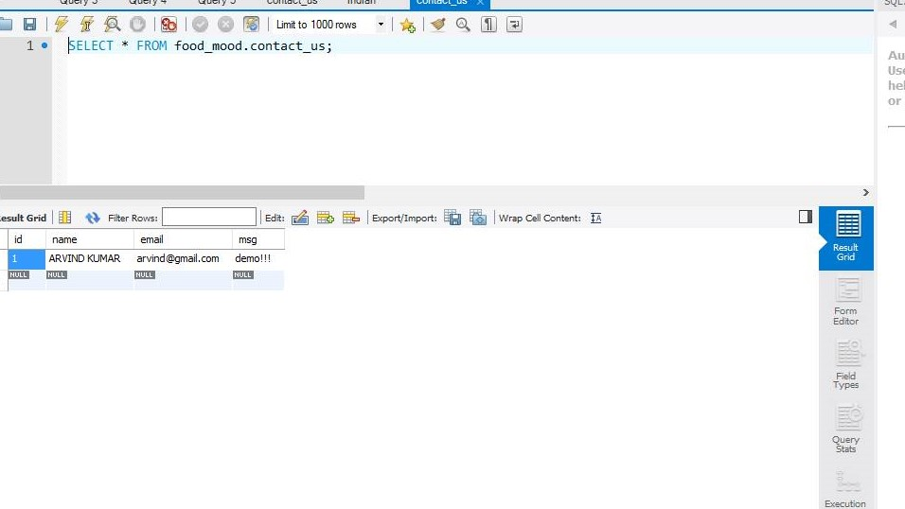

***INDIAN TABLE:***

**DESCRIPTION:** This table contains attributes- id, name (name of recipe), type, category, ingredient, step and image of the recipe uploaded by the user.

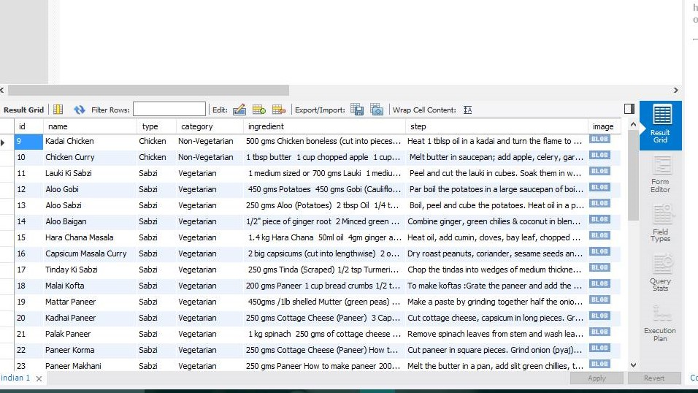

**SNAPSHOTS**

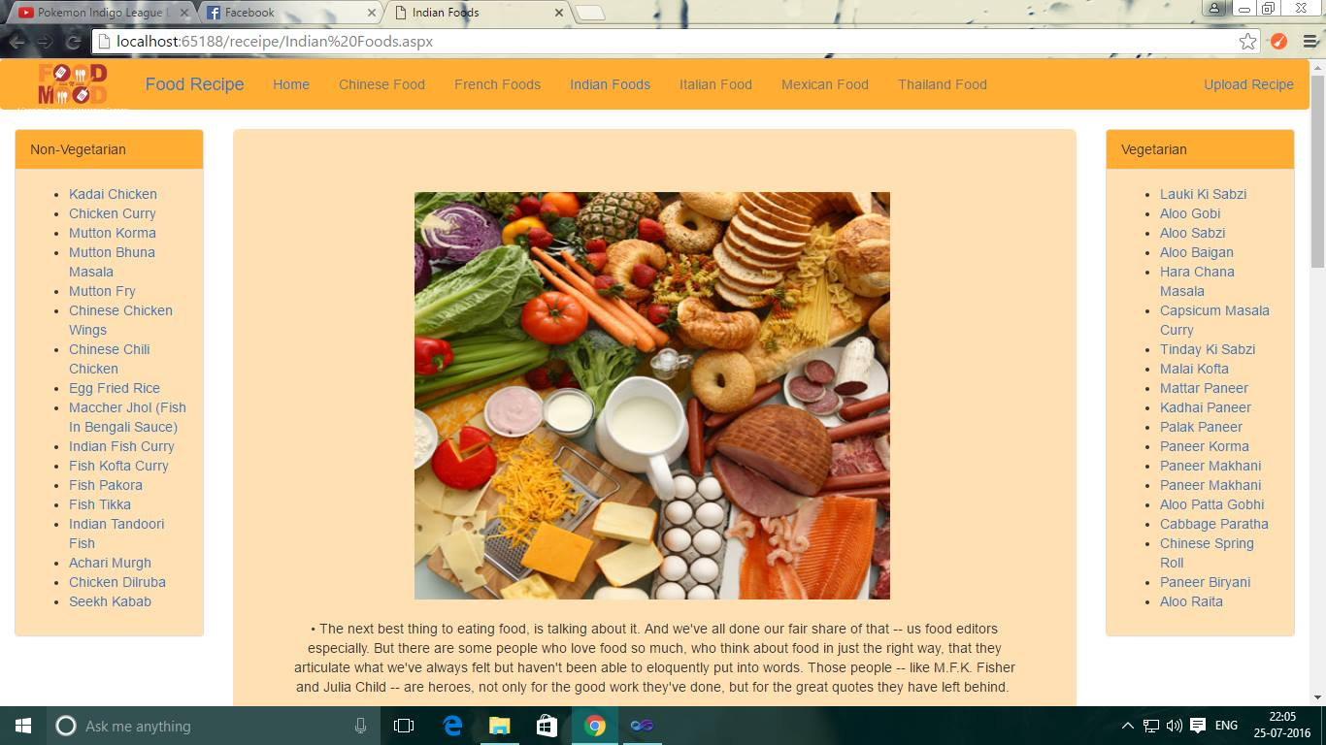

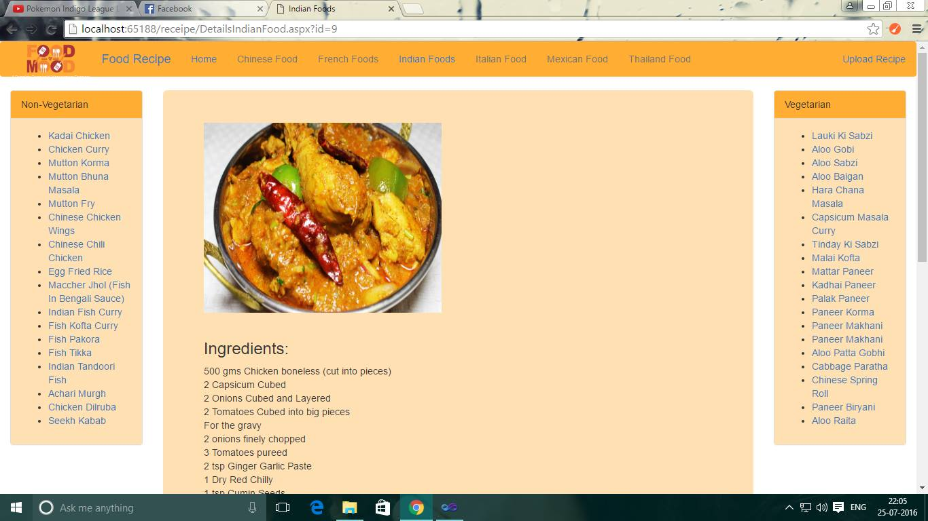

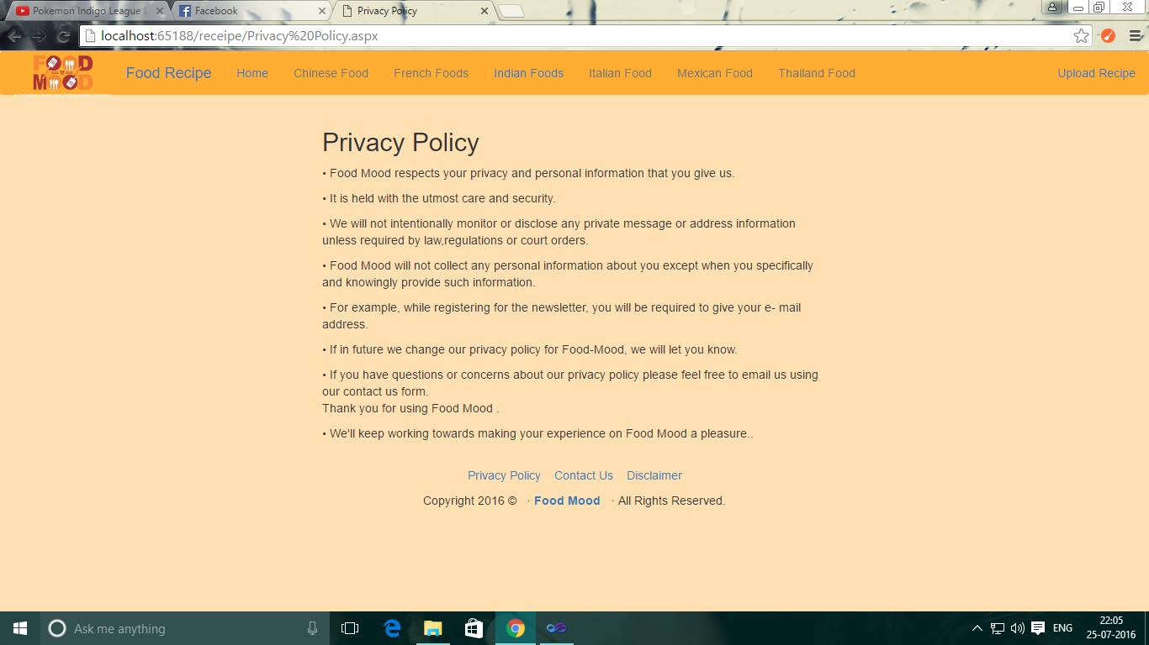

**SAMPLE CODING**

In this phase the actual complete project code is developed. With the written code segment the comments and description corresponding to code also should be given.

***Testing***:

As the coding phase precedes every unit module is tested before being delivered to the next phase. All the modules that have been developed before and tested individually are integrated in this phase. Final Software is then tested under System Testing.

***Implementation & Maintenance:***

Once the System passes all the test during System testing the system is delivered to the Customer where it has to be implemented successfully.

Maintenance phase that includes addition of modules, modification of the hardware and software.

***HTML CODE*:-**

***Master page:***

. <%@ Master Language="VB" CodeFile="MasterPage.master.vb" Inherits="MasterPage" %>

<!DOCTYPE html PUBLIC "-//W3C//DTD XHTML 1.0 Transitional//EN" "http://www.w3.org/TR/xhtml1/DTD/xhtml1-transitional.dtd">

<html xmlns="http://www.w3.org/1999/xhtml">

<head runat="server">

<title>Home</title>

<meta charset="utf-8">

<meta name="viewport" content="width=device-width, initial-scale=1">

<link rel="stylesheet" href="css/bootstrap.min.css">

<script src="jquery.min.js"></script>

<script src="js/bootstrap.min.js"></script>

<link href="Style.css" rel="stylesheet" />

<asp:ContentPlaceHolder id="head" runat="server">

</asp:ContentPlaceHolder>

</head>

<body>

<form id="form1" runat="server">

<!-- header begin -->

<nav class="navbar navbar-light" style="background-color: #ffad33;">

<div class="container-fluid">

<div class="navbar-header">

<a class="navbar-brand" href="#" style="padding-top:2px">

<img alt="Brand" style="width:auto;height:3em; "src="logo.png">

</a>

</div>

<div class="navbar-header">

<a class="navbar-brand" href="#">Food Recipe</a>

</div>

<ul class="nav navbar-nav">

<li class="active"><a href="Home.aspx">Home</a></li>

<li class="disabled"><a href="Chinese Food.aspx">Chinese Food</a></li>

<li class="disabled"><a href="">French Foods</a></li>

<li class="active"><a href="Indian Foods.aspx">Indian Foods</a></li>

<li class="disabled"><a href="">Italian Food</a></li>

</ul>

</div>

</nav>

<!-- header end -->

<div>

<asp:ContentPlaceHolder ID="MainContentPlaceHolder" runat="server">

</asp:ContentPlaceHolder>

</div>

<footer class="site-footer" itemscope itemtype="http://schema.org/WPFooter">

<div class=" wrap flinks" align="center">

<p>

<a href="Privacy Policy.aspx">Privacy Policy</a>&nbsp;&nbsp;&nbsp;&nbsp;<a href="Disclaimer.aspx">Disclaimer</a>

</p>

</div>

</div>

<script type='text/javascript'>

</script>

</footer>

<!--footer end -->

</form>

</body>

</html>

***Admin page:***

<%@ Page Title="" Language="VB" MasterPageFile="~/MasterPage.master" AutoEventWireup="false" CodeFile="Admin.aspx.vb" Inherits="Admin" %>

<asp:Content ID="Content1" ContentPlaceHolderID="head" Runat="Server">

<style>

body

{

background-color: #ffe0b3;

}

</style>

</asp:Content>

<asp:Content ID="Content2" ContentPlaceHolderID="MainContentPlaceHolder" Runat="Server">

<div class="container-fluid" style="max-width:600px;background-color: #ffe0b3; margin:auto">

<div class="jumbotron" style="background-color: #ffe0b3;">

<h2>Welcome Admin!!</h2>

<asp:Label ID="Label1" runat="server" Text="Label"></asp:Label>

<form role="form">

<div class="form-group">

<label for="name" runat="server">Name:</label>

<input type="text" runat="server" class="form-control" id="name">

</div>

<div class="form-group">

<label for="type" runat="server">Food Type:</label>

<input type="text" runat="server" class="form-control" id="type">

</div>

<div class="form-group">

<label for="category" runat="server">Food Category:</label>

<input type="text" runat="server" class="form-control" id="category">

</div>

<asp:FileUpload ID="image1" runat="server" />

<asp:Button ID="Button1" runat="server" Text="Submit" />

</form>

</div>

</div>

</asp:Content>

***Indian food page:***

<%@ Page Title="Indian Foods" Language="VB" MasterPageFile="~/MasterPage2.master" AutoEventWireup="false" CodeFile="DetailsIndianFood.aspx.vb" Inherits="Indian_Foods" %>

<asp:Content ID="Content1" ContentPlaceHolderID="LeftContentPlaceHolder" Runat="Server">

<div class="panel panel-default">

<div class="panel-heading" style="background-color:#ffad33;">Non-Vegetarian</div>

<div class="panel-body" style="background-color: #ffe0b3;">

<ul id="list1" runat="server">

</ul>

</div>

</div>

</asp:Content>

<asp:Content ID="Center" ContentPlaceHolderID="ContentPlaceHolder1" Visible="false" runat="server">

<div id="content">

<asp:Image ID="Image1" style="width:25em;height:20em;" align="center" runat="server" /><br /><br />

<h3>Ingredients:<br /></h3>

<div id="ingredients" runat="server">

</div><br /><br />

<div class="panel panel-default">

<div class="panel-heading" style="background-color:#ffad33;">Vegetarian</div>

<div class="panel-body" style="background-color: #ffe0b3;">

<ul id="list2" runat="server">

</ul>

</div>

</div>

</asp:Content>

Master page 2:

<%@ Master Language="VB" MasterPageFile="~/MasterPage.master" AutoEventWireup="false" CodeFile="MasterPage2.master.vb" Inherits="MasterPage2" %>

<asp:Content ID="Content1" ContentPlaceHolderID="head" Runat="Server">

</asp:Content>

<asp:Content ID="Content2" ContentPlaceHolderID="MainContentPlaceHolder" Runat="Server">

<div class="container-fluid">

<div class="row">

<div class="col-md-2">

<asp:ContentPlaceHolder ID="LeftContentPlaceHolder" runat="server">

</asp:ContentPlaceHolder>

<%-- --%>

</div>

<div class="col-md-8">

<div class="jumbotron" style="background-color:#ffe0b3;">

<asp:ContentPlaceHolder ID="ContentPlaceHolder1" runat="server">

<div class="text">

<p><div class="text" align="center" style="padding-top:2px">

<img alt="Brand" style="width:35em;height:30em; "src="food2.jpg">

<br /> <br />

&#149; The next best thing to eating food, is talking about it. And we've all done our fair share of that -- us food editors especially. But there are some people who love food so much, who think about food in just the right way, that they articulate what we've always felt but haven't been able to eloquently put into words. Those people -- like <br />

<br />

&#149; “If you're afraid of butter, use cream." -Julia Child <br />

<br />

&#149; “First we eat, then we do everything else.” -M.F.K. Fisher <br /><br />

<img alt="Brand" style="width:35em;height:30em; "src="food.jpg"><br /><br />

<br />

&#149; "Life is uncertain. Eat dessert first." -Ernestine Ulmer <br />

<br />

&#149; "In wine there is wisdom, in beer there is strength, in water there is bacteria." -David Auerbach <br />

<br />

&#149; "You don't need a silver fork to eat good food." -Paul Prudhomme <br /><br />

&#149; "My doctor told me I had to stop throwing intimate dinners for four unless there are three other people." -Orson Welles <br />

<br />

<br />

&#149;“It's difficult to think anything but pleasant thoughts while eating a homegrown

</div>

</div>

<%-- --%>

</div>

</asp:Content>

***VB.NET CODE*:-**

***Indian Food Page:***

Imports Microsoft.VisualBasic

Imports System.Data

Imports System.Data.OleDb

Imports System.IO

Imports MySql.Data.MySqlClient

Partial Class Indian_Foods

Inherits System.Web.UI.Page

Protected Sub Page_Load(ByVal sender As Object, ByVal e As System.EventArgs) Handles Me.Load

Dim mycon As MySqlConnection = New MySqlConnection("Server=localhost; Database=Food_Mood;User Id=root;Password=1234")

Try

mycon.Open()

Dim mycmd As MySqlCommand = New MySqlCommand("SELECT * FROM

Dim list1Content As String = ""

While myreader.Read

myreader.GetString("name")

list1Content += "<li><a href='DetailsIndianFood.aspx?id=" & myreader.GetString("id") & "'>" & myreader.GetString("name") & "</a></li>"

End While

myreader.Close()

list1.InnerHtml = list1Content

While myreader1.Read

myreader1.GetString("name")

list1Content1 += "<li><a href='DetailsIndianFood.aspx?id=" & myreader1.GetString("id") & "'>" & myreader1.GetString("name") & "</a></li>"

End While

myreader1.Close()

list2.InnerHtml = list1Content1

Catch ex As Exception

Response.Write(ex.ToString())

Finally

mycon.Close()

End Try

End Sub

End Class

***Details of Indian Food***

Imports MySql.Data.MySqlClient

Partial Class Indian_Foods

Inherits System.Web.UI.Page

Dim mycon As MySqlConnection = New MySqlConnection("Server=localhost; Database=Food_Mood;User Id=root;Password=1234")

Protected Sub Page_Load(ByVal sender As Object, ByVal e As System.EventArgs) Handles Me.Load

If Not Request.QueryString.GetValues("id") Is Nothing Then

Dim id As String = Request.QueryString("id").ToString

mycon.Open()

Dim mycmd As MySqlCommand = New MySqlCommand("SELECT * FROM

Replace(Environment.NewLine, "<br/>")

steps.InnerHtml = reader.GetString("step").Replace(Environment.NewLine, "<br/>")

reader.Close()

mycon.Close()

End If

Try

mycon.Open()

Dim mycmd As MySqlCommand = New MySqlCommand("SELECT * FROM Food_Mood.indian where category='Non-Vegetarian';", mycon)

Dim myreader As MySqlDataReader = mycmd.ExecuteReader()

Dim list1Content As String = ""

While myreader.Read

myreader.GetString("name")

list1Content += "<li><a href='DetailsIndianFood.aspx" & "?id=" & myreader.GetString("id") & "'>" & myreader.GetString("name") & "</a></li>"

End While

myreader.Close()

list1.InnerHtml = list1Content

While myreader1.Read

myreader1.GetString("name")

list1Content1 += "<li><a href='DetailsIndianFood.aspx" & "?id=" & myreader1.GetString("id") & "'>" & myreader1.GetString("name") & "</a></li>"

End While

myreader1.Close()

list2.InnerHtml = list1Content1

Catch ex As Exception

Response.Write(ex.ToString())

Finally

mycon.Close()

End Try

End Sub

End Class

CSS CODE

html {

font-family: sans-serif;

-webkit-text-size-adjust: 100%;

-ms-text-size-adjust: 100%;

}

body {

margin: 0;

}

summary {

display: block;

}

audio,

canvas,

progress,

video {

display: inline-block;

vertical-align: baseline;

}

audio:not([controls]) {

display: none;

height: 0;

}

[hidden],

template {

display: none;

}

a {

background-color: transparent;

}

a:active,

a:hover {

outline: 0;

}

abbr[title] {

border-bottom: 1px dotted;

}

b,

strong {

font-weight: bold;

}

dfn {

font-style: italic;

}

h1 {

margin: .67em 0;

font-size: 2em;

}

mark {

color: #000;

background: #ff0;

}

small {

font-size: 80%;

}

sub,

sup {

position: relative;

font-size: 75%;

line-height: 0;

vertical-align: baseline;

}

sup {

top: -.5em;

}

sub {

bottom: -.25em;

}

img {

border: 0;

}

svg:not(:root) {

overflow: hidden;

}

figure {

margin: 1em 40px;

}

hr {

height: 0;

-webkit-box-sizing: content-box;

-moz-box-sizing: content-box;

box-sizing: content-box;

}

pre {

overflow: auto;

}

code,

kbd,

pre,

samp {

font-family: monospace, monospace;

font-size: 1em;

}

button,

input,

optgroup,

select,

textarea {

margin: 0;

font: inherit;

color: inherit;

}

button {

overflow: visible;

}

button,

select {

text-transform: none;

}

button,

html input[type="button"],

input[type="reset"],

input[type="submit"] {

-webkit-appearance: button;

cursor: pointer;

}

button[disabled],

html input[disabled] {

cursor: default;

}

input {

line-height: normal;

}

input[type="checkbox"],

input[type="radio"] {

-webkit-box-sizing: border-box;

-moz-box-sizing: border-box;

box-sizing: border-box;

padding: 0;

}

input[type="number"]::-webkit-inner-spin-button,

input[type="number"]::-webkit-outer-spin-button {

height: auto;

}

input[type="search"] {

-webkit-box-sizing: content-box;

-moz-box-sizing: content-box;

box-sizing: content-box;

-webkit-appearance: textfield;

}

input[type="search"]::-webkit-search-cancel-button,

input[type="search"]::-webkit-search-decoration {

-webkit-appearance: none;

}

fieldset {

padding: .35em .625em .75em;

margin: 0 2px;

border: 1px solid #c0c0c0;

}

legend {

padding: 0;

border: 0;

}

textarea {

overflow: auto;

}

optgroup {

font-weight: bold;

}

table {

border-spacing: 0;

border-collapse: collapse;

}

td,

th {

padding: 0;

}

{

color: #000 !important;

text-shadow: none !important;

background: transparent !important;

-webkit-box-shadow: none !important;

box-shadow: none !important;

}

**TESTING**

***System testing and installation***

***Introduction:***

System testing and implementation is final phase of any system development life cycle. As a step in system development cycle, testing and implementation consists of final steps that put the new system into operation.

***Forms and program testing***

First the system deals with large number of state, complex logic activities. So some error might occur in the system. Errors may be in software, which is known as **“**software errors**”**, i.e. the software does not do what the requirement says. So an exhaustive and through testing must be conducted to ascertain whether the system produce right result.

Testing is vital to the success of the system. System testing makes a logical assumption that if all parts of a system are correct, the goal of system design will be successfully achieved. Another reason for system testing is to check its utility as a user oriented vehicle before implementation. This system can be designed according to the requirements of the system and needs of the user. Yet complete accuracy cannot always be claimed. So, an exhaustive and through testing of the system produced the correct results.

The testing has been done in several stages. First each program module was tested as a single program, which also known as module testing or unit testing. In unit testing a set of data as input was given to the module and observed what the output is. In addition, the logic and boundary condition for input and output data has also been checked. The interface between this module and others was also check for correctness. **Integration and system testing**

When individual program modules work properly, we combine the module into a working system. This integration is planned and coordinated so that an error occurs; we have an idea of what caused the former. Integration testing is a process of verifying that the component of a system work together as described in the program design and system specification.

For testing the entire system was viewed as a hierarchy of modules we began with the module at the highest level of design and worked down. Next modules to be tested are those that call previously tested modules.

In each of the individual program and forms were found to be working properly they were combined into a working module and then tested. The integration is planned and coordinated in such a way that when an error occurs it would give an idea of where and why it occurred.

**Functional testing**

Once we are sure that information is passed among the module according to the design prescription we tested to ensure whether the function described the requirement specification are performed be the integrated system. System testing checks the readiness and accuracy of the system to access update and retrieve data from new files. Once the program becomes available, test data are read into the computer and process against the files for testing. If successful, program is run with live data.

**Acceptance testing**

When all the tests on the system were over the users were involved to make **sure that the system was working according to the users’ exceptions. Thus** finally the user did acceptance.

**Installation testing**

When acceptance test was completed, the acceptance system was installed in the environment in which it will be used and a final installation test was performed to make sure, that the system would function, as it should.

**Implementation**

Ones the system was tested satisfactory, then comes the implementation of the system implementation is the process of migrating from the old system to the new system.

To implement the system, modular conversion with parallel run strategy has been adopted, because this is the safest conversion approach. System is implemented step by step in parallel with existing system.

MAINTAINANCE

Software maintenance denotes any changes made to a software product after it has been delivered. Every software product continues to evolve after its development through maintenance efforts.

The 3 basic types of software maintenance are as follows:

**Corrective**: Corrective maintenance of a software product becomes necessary to rectify the bugs observed while the system is in use.

**Adaptive**: A software product might need maintenance when the customers need the product to run on new platforms, on new operating systems, or when they need the product to be interfaced with new hardware or software.

**Perfective**: A software product needs maintenance to support the new features that users want it to support, to change different functionalities of the system according to customer demands, or to enhance the performance of the system.

Our developed system readily satisfies the above criteria and is thus easily **maintainable. It doesn’t require any extra effort on behalf of the user.**

**FUTURE SCOPE**

1. At this stage of the project we have implemented only Indian recipes but it can be extended.
2. As more users register, the database will keep growing.
3. Liking, sharing and commenting on the post.
4. Add youtube videos.
5. **Link with user’s email id so that important notices can also be automatically sent** to their mail.
6. Creating a messenger.
7. Creating a mobile application.

**REFERENCES**

This section gives you the name of the books sources required for the development of the project.

1. Visual basic Black book.
2. www.**tutorials**point.com/**mysql**
3. [www.**asptutorial**.info](http://www.asptutorial.info)

**You can find out live hosted project at:**

[**http://worldrecipe.azurewebsites.net/Home.aspx**](http://worldrecipe.azurewebsites.net/Home.aspx)